Story Care & Share/ Stori Gofal a Rhannu

Fortnightly storytelling gatherings for people affected by cancer and life limiting illnesses at The Ffwrnes Fach, Ffwrnes Theatre, Llanelli. Participants creatively worked with professional poets, writers and storytellers in a safe space over tea and cake. To find life stories, create life stories, tell life stories and listen to others.
Project Aims: -
- To help people feel less lonely and isolated.
- To improve the mental health and well -being of our community
Storytelling was our main art form for the project, and we used creative writing, poetry and the spoken word to explore this. Eleanor Shaw our artistic director was the project lead facilitator and coordinator, with Alun Gibbard as our welsh language writer and our guest facilitators;

- Storyteller Steve Killick ( www.stevekillick.com)
- Poet Rhian Elizabeth ( www.parthianbooks.com) ,
- Mel Perry & Dominic Williams from Write4word (https://www.facebook.com/Write4Word-255816194466315/)
- Alex Waters ( www.3principleswales.com) ( Project Coach)

Project Details:-
- 5 sessions @ 3hours
- 1 Sharing afternoon ( 40 people attended and listen to participants share stories)
- Project Costs = £7,000
- ACW Research and Development Grant of £5,000/ PSU funds £2,000
- 13 Participants
- Project Started on 18.12.2018 and ended on 13.02.2019
- Project Supported by; Tenovus cancer Care, Macmillan, Carmarthenshire County Council, Llanelli Town Council, Ffwrnes Theatre, 50+ network, Alzheimers Society, Hywel Dda

Project Outcomes:-
Alex Waters used WEMWBS & Personal Issue envelopes at the start and the end of the project to measure well being outcomes. Eleanor Shaw led a creative evaluation at the end of the project, participants were invited to a table of objects and were asked to place a written comment next to one or two objects with a response or feeling.

Analysis of Scores
WEMWBS:
Out of the 10 participants who completed the second WEMWBS:
8 out of 10 people’s scores revealed an increase in wellbeing across
the scale and 2 people’s scores revealed no change* in scores (no
increase or decrease in wellbeing)

PIE:
12 participants completed the PIE scoring:
Out of the one or two confidential issues that participants chose, 8
reported that their scores had decreased which reveals an increase
in resilience and wellbeing. Two people reported an increase in score
which reveals a decrease in resilience and wellbeing*. And two people
reported that their scores had not changed* (no increase or decrease in
scores).

Creative Evaluation
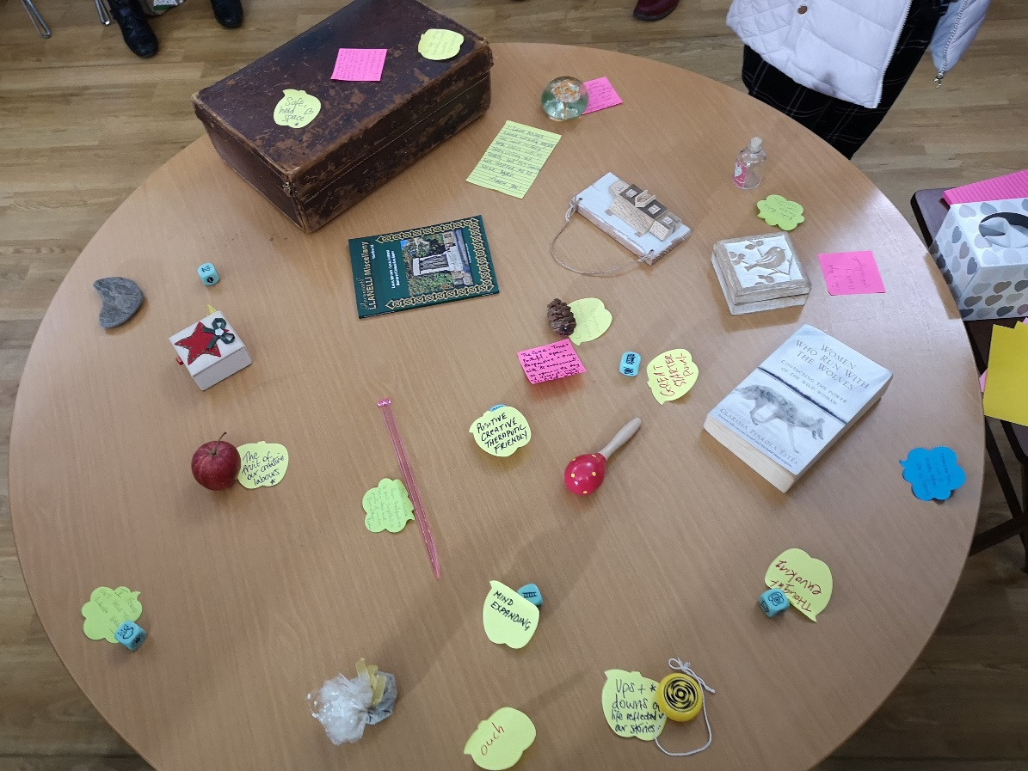

What is next?
All participants would like the project to continue and we have been signposted more participants from Macmillan. PSU funds will enable us to start the project again in March and we are currently seeking more sustainable, long term funding.

The evaluation report will be finalised by April 2019.

Eleanor Shaw
PeopleSpeak Up

